Activity 1.2: Using the pen to draw shapes
Follow these instructions to complete your first Scratch program.
You are going to use the pen extension to get the cat to draw different shapes.
- Create a new Scratch program.
- Select the ‘Add Extensions’ icon.

- Select the ‘Pen’ extension.

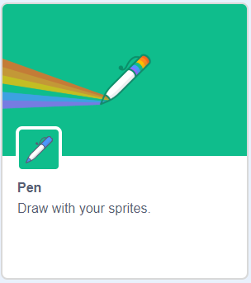

- Locate the blocks and create the following program:
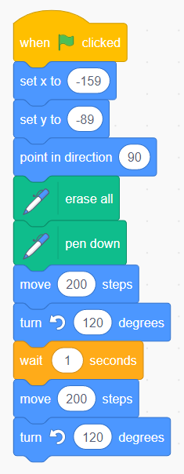
These blocks are the same as blocks 7 and 8. They move the cat 200 steps in the direction it is facing and then turn the cat 120 degrees to the left.

This block makes the cat wait for 1 second before it does what the blocks below tell it to do.

This block tells the program to do what comes after it when the green flag is clicked.

This block says the direction the cat will face in, in degrees. 0 degrees is north on a compass.
.

These blocks set the start location of the cat on the horizontal axis (x) and vertical axis (y).

These blocks move the cat 200 steps in the direction it is facing and then turn the cat 120 degrees to the left.

This block puts the pen on the stage to draw.

This block deletes any drawings on the stage.

- Finally, screenshot your blocks and paste the screenshot into your evidence document.

